**CE Web Site Journey Content Authoring**

CE journey content is based on the experience written up by teachers who took the tour. CE journey organizes teacher’s tour report into the following categories:

* Teacher’s professional bio – information about the teacher such as the district, the school, the subject, and the grade.
* Photos – the tours photos the teacher took during the tour.
* Diary – the daily report the teacher wrote up.
* Curriculum – the class information the teacher participated in during the tour.

The steps to create a CE journey content are:

**Step 1: Create journey subfolder for each teacher**

The subfolder should be created under /content/tours/journey folder. The name of the subfolder should be the teacher first and last name with no space in-between. For example, the subfolder for Siri Hulbert who participated in 2013 summer tour would be named *SiriHulbert*.

**Step 2: Create journey photos subfolder**

The photos subfolder should be created under the subfolder you created above. For example, the photos subfolder for Siri Hulbert who participated in 2013 summer tour would be */content/tours/journey/SiriHulbert/photos*.

**Step 3: Create journey xml content file**

To start out a journey xml file, use the journey template file */content/journey-template.xml*. Make a copy of the template, rename it, and then move it to the content subfolder you created above. **Note:** the journey filename should be the same as the subfolder name. For example, for Siri Hulbert above, the content file is *SiriHulbert.xml.*

**Step 4: Add journey content**

Add the journey content to the file. The best way is to use an existing journey content file as example to do your editing. Put all tour photos to *photos* subfolder.

**Step 5: Create journey web page for the content**

Use web page generator tool in CE site to help you create a web page to render your content. Please refer to document *Generating CE Web Page for Content* for details.

**Step 6: Make the journey page as feature journey**

If you want to feature the journey page you just created, you can edit the menu content file, */content/cemenu.xml* to point the *journey* submenu to the journey web page. For example, you would point it to */content/tours/journey/SiriHulbert/SiriHulbert.html* to feature Siri’s journey when the *journey* submenu is selected.

**Step 6: Test your page**

Test your page to ensure sure it is rendered as intended.

**Sample Screen Shots for Journey Page**

The screen shots below show the content of Siri Hulbert journey page:

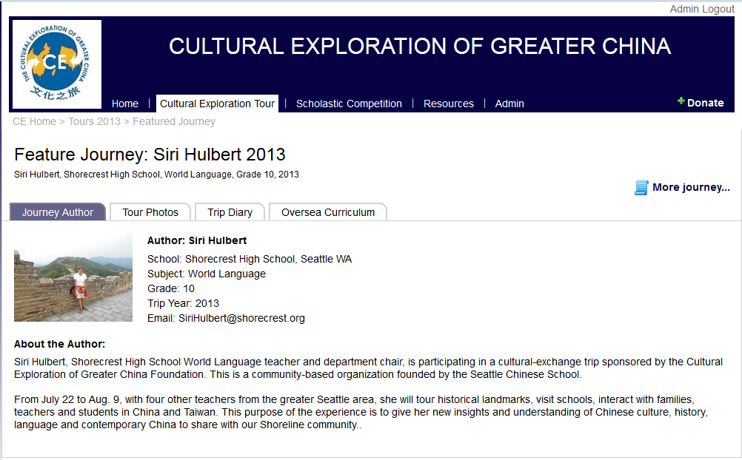

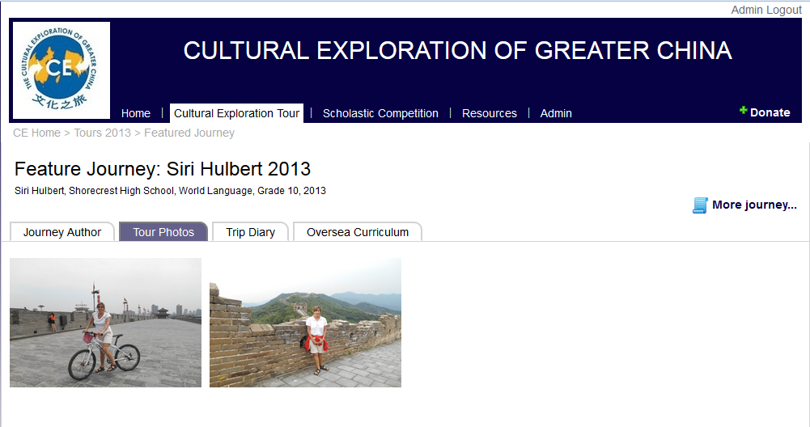

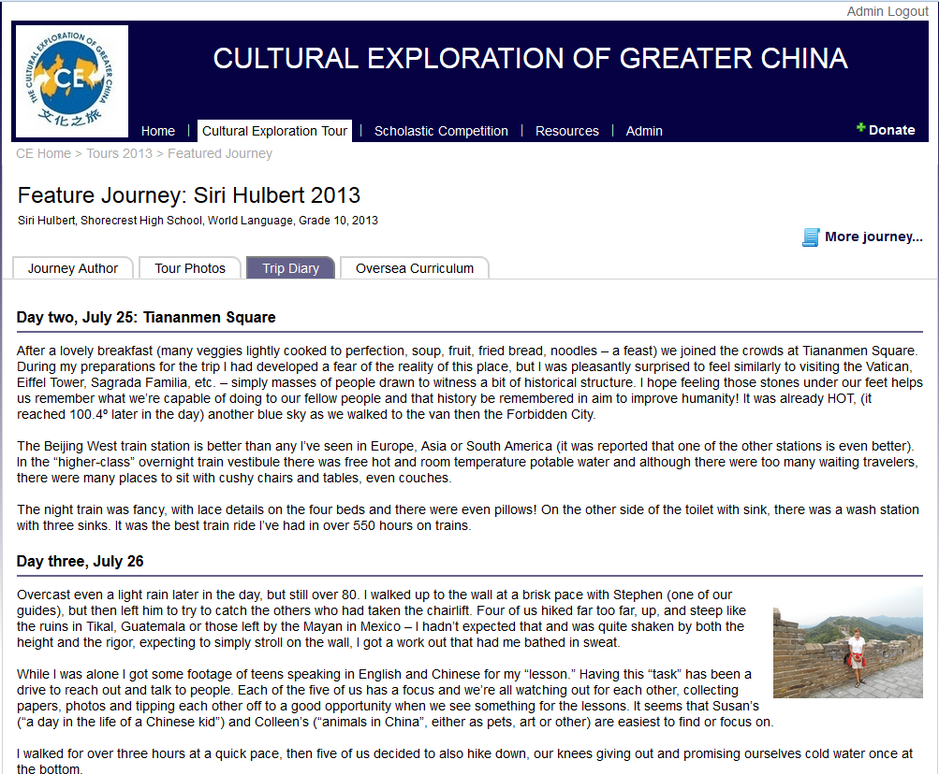

**Journey template file code listing**

?xml version="1.0" encoding="utf-8" ?>

<ce>

<journey title="..." align="left" rootUrl="/Content/Tours/Journey/...">

<bio>

<name first="..." last="..." display="..." />

<email></email>

<phone></phone>

<address></address>

<city></city>

<state></state>

<school></school>

<grade></grade>

<subject></subject>

<year></year>

<photo>/content/tours/journey/.../photos/...</photo>

<about>

<![CDATA[

put any text here including html tags or Chinese words.

]]>

</about>

</bio>

<album folder="Photos" align="right">

</album>

<diary>

<articles>

<article title="...">

<paragraph>

<text>

<![CDATA[

put diart text here

]]>

</text>

</paragraph>

</article>

<article title="...">

<paragraph>

<picture url="/content/tours/journey/.../photos/..." position="right" />

<text>

<![CDATA[

put diart text here

]]>

</text>

</paragraph>

</article>

</articles>

</diary>

<testimony title="very short text">

<quote>

put quote text here

</quote>

</testimony>

</journey>

</ce>